This abstract template is an optional tool that can be used to prepare your information
for the online submission form. The template is not required and should not be submitted.

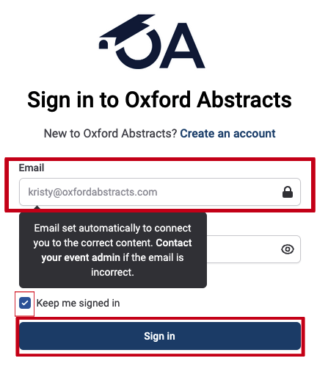
Oxford Abstracts
ISI is using the Oxford Abstracts platform for abstract submissions.
You will be prompted to create a free Oxford Abstracts account prior to filling out the submission form. Through this account, you will be able to save your work, edit the submission, and review
the information at any time.

* Denotes required information

Session Type*
Select your preferred session type.
- Panel Session
- Education Session
- Lightning Round Session
- Project Showcase Session
- Poster Session

Topics*
Choose the sustainability topics that best fit your submission. Select up to 3 topics.
- Best practices in (your topic)  - Biodiversity & natural capital  - Carbon  - Circular economy  - Climate adaptation  - Climate change & public health  - Driving efficiency & cost savings  - Driving sustainability within the political climate  - Emerging markets  - Envision in “mega” projects  - Envision project case studies  - ESG and metrics  - Funding and investment | - Impact on local communities  - Integrated infrastructure  - Materials selection  - Regulatory frameworks & local regulations  - Social sustainability  - Stakeholder engagement  - Supply chain  - Sustainability in education  - Technologies supporting sustainable infrastructure  - Value of Envision beyond verification  - Workforce skill building

Title*
Enter the FULL TITLE of your abstract. (max 20 words)

Abstract*
Enter an abstract of your presentation, including how it relates to Envision (max 300 words)

Infrastructure Sector*
Does your abstract highlight any types of infrastructure? If applicable, select all that apply.
- Not applicable  - Information  - Transportation  - Water / Wastewater | - Energy  - Landscape / Environment  - Waste  - Other

Learning Objectives
Add 2-5 concise, clear, measurable, and achievable learning objectives and goals that will be met at the end of your presentation. Use active verbs when writing learning objectives, such as acquire, analyze, apply, assess, build, clarify, compare, define, demonstrate, describe, determine, differentiate, discover, etc. (2 learning objectives are required)
Objective 1*

Objective 2*

Objective 3

Objective 4

Objective 5

Presenters and affiliations*
Enter names of ALL anticipated presenters here – including yourself if you will be a presenter. Up to 4 presenters.

Presenter 1
First Name* |  | Last Name* |  | Credentials
Email* |  |  | Professional Title*
Short Bio (max 150 words)*
Organization* | City |  | State / Province |  | Country

Presenter 2
Professional Title* |  | First Name* |  | Last Name*
Credentials |  |  | Email*
Short Bio (max 150 words)*
Organization* | City |  | State / Province |  | Country

Presenter 3
Professional Title* |  | First Name* |  | Last Name*
Credentials |  |  | Email*
Short Bio (max 150 words)*
Organization* | City |  | State / Province |  | Country

Presenter 4
Professional Title* |  | First Name* |  | Last Name*
Credentials |  |  | Email*
Short Bio (max 150 words)*
Organization* | City |  | State / Province |  | Country

Permission to publish*
If accepted, I give permission to publish the presentation on electronic media. This includes adding a recording of the presentation to ISI's educational platform and sharing a pdf of presented slides.

Approvals*
I confirm that this submission has been approved by all presenters.

Attendance*
I confirm that at least one presenter is available to attend and present at the Conference if abstract is accepted.

